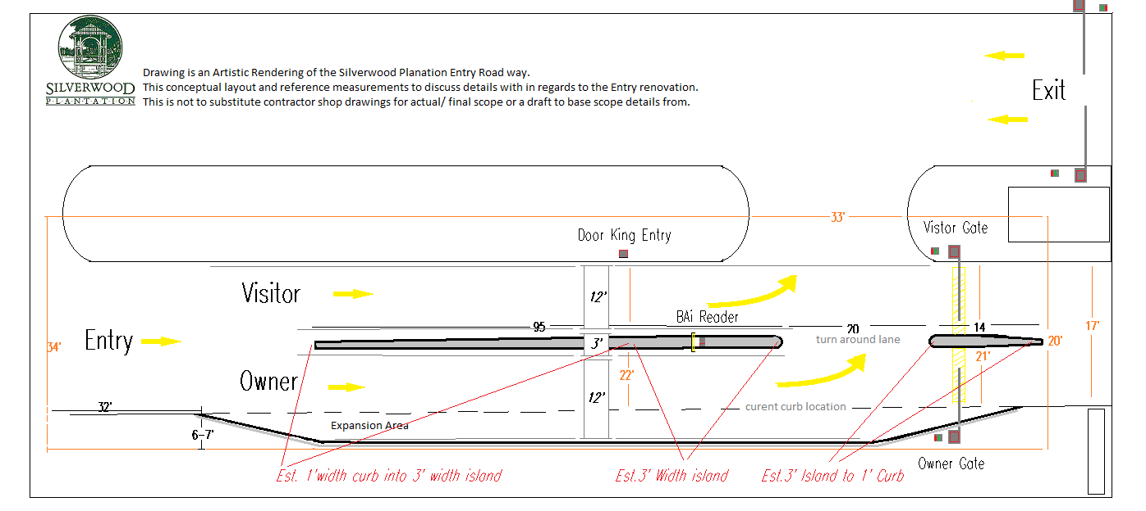

Silverwood Plantation Conceptual Drawing of Roadway Expansion.
Contractors are required to present actual drawings with proposal for approval.

Key Features:

Expand road way to increase total road way; creating 2 lanes.

Lanes should be minimum of 12’ wide; accommodate all vehicles.

Install Island/ Curb Divider.

Small curb area to separate the two lanes.

Curb is to form the small island between the two lanes; Access equipment location.

Small divider to mirror the center curb; merging area into the property.

Allowance between island and divider for turnaround point.

Expansion area:

Removal of existing curb and earth.

Install extended/ paved road way to suitably increase the overall road; as concept.

Describe all details of work to complete; such as, but not limited too.

Demolition of site; installation of expansion and renovation

Paving; Concrete curb

Clean up and debris removal

Install curb to form the expansion.

